Project Planning Phase

**Project Planning Template (Product Backlog, Sprint Planning, Stories, Story points)**

|  |  |
| --- | --- |
| Team ID | PNT2022TMI11670 |
| Project Name | Project – IOT-Based Safety Gadget for Child Safety Monitoring and Notification |
| Maximum Marks | 8 Marks |

# Product Backlog, Sprint Schedule, and Estimation (4 Marks)

Use the below template to create a product backlog and sprint schedule

|  |  |  |  |  |  |
| --- | --- | --- | --- | --- | --- |
| **Sprint** | **Functional Requirement (Epic)** | **User Story Number** | **User Story / Task** | **Story Points** | **Priority** |
| Sprint-1 | Registration | USN-1 | As a user, I can register for the application by  entering my email, and password, and confirming my password. | 4 | High |
| Sprint-1 | Confirmation Email | USN-2 | As a user, I will receive a confirmation email once I have registered for the application | 4 | High |
| Sprint-1 | Authentication | USN-3 | As a user, I can register for the application through Gmail and mobile app. | 4 | Medium |
| Sprint-1 | Login | USN-4 | As a user, I can log into the application by entering email & password | 4 | High |
| Sprint-1 | Dashboard | USN-5 | As a user, I need to be able to view the functions that I can perform | 4 | High |
| Sprint-2 | Notification | USN-1 | As a user, I should be able to notify my parent and guardian in emergency situations | 10 | High |
| Sprint-2 | Store data | USN-2 | As a user, I need to continuously store my location data into the database. | 10 | Medium |
| Sprint-3 | Communication | USN-3,1 | I should be able to communicate with my parents | 6 | Low |

|  |  |  |  |  |  |
| --- | --- | --- | --- | --- | --- |
| **Sprint** | **Functional**  **Requirement (Epic)** | **User Story**  **Number** | **User Story / Task** | **Story Points** | **Priority** |
| Sprint-3 | IoT Device – Watson communication | USN-1,4 | The data from IoT device should reach IBM Cloud | 7 | Medium |
| Sprint-3 | Node RED- Cloudant DB communication | USN-5,2 | The data stored in IBM Cloud should be properly integrated with Cloudant DB | 7 | High |
| Sprint-4 | User – WebUI interface | USN-1,4 | The Web UI should get inputs from the user | 6 | High |
| Sprint-4 | Geofencing | USN-2,3,5 | The geofencing of the child should be done based on the geographical coordinates | 7 | High |

# Project Tracker, Velocity & Burndown Chart: (4 Marks)

|  |  |  |  |  |  |  |
| --- | --- | --- | --- | --- | --- | --- |
| **Sprint** | **Total Story Points** | **Duration** | **Sprint Start Date** | **Sprint End Date (Planned)** | **Story Points Completed (as on Planned End Date)** | **Sprint Release Date (Actual)** |
| Sprint-1 | 20 | 6 Days | 24 Oct 2022 | 29 Oct 2022 | 20 | 29 Oct 2022 |
| Sprint-2 | 20 | 6 Days | 31 Oct 2022 | 05 Nov 2022 | 20 | 05 Nov 2022 |
| Sprint-3 | 20 | 6 Days | 07 Nov 2022 | 12 Nov 2022 | 20 | 12 Nov 2022 |
| Sprint-4 | 20 | 6 Days | 14 Nov 2022 | 19 Nov 2022 | 20 | 19 Nov 2022 |
|  |  |  |  |  |  |  |
|  |  |  |  |  |  |  |
|  |  |  |  |  |  |  |
|  |  |  |  |  |  |  |

**Velocity:**

Imagine we have a 10-day sprint duration, and the velocity of the team is 20 (points per sprint). Let’s calculate the team’s average velocity (AV) per iteration unit (story points per day)

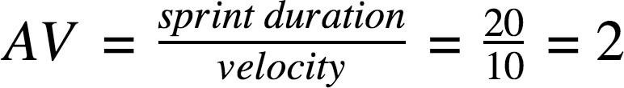

# Burndown Chart:

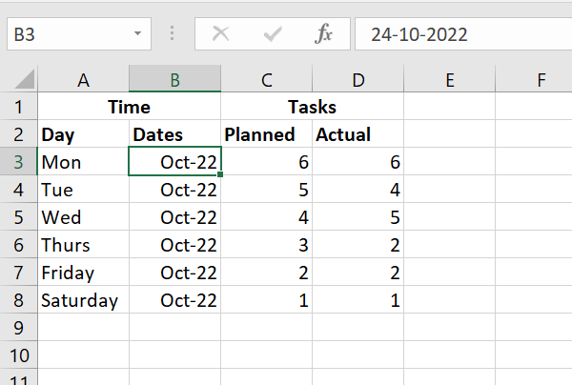



Burndown Chart

Planned

Actual

7

6

6

5

5

5

4

4

4

3

3

2

2

2

1 1

0

Oct-22 Oct-22 Oct-22 Oct-22 Oct-22 Oct-22